Cooperative Learning (STAD) Lesson Plan

Author: Sierra Staggs

Date Created: 3-25-14

Subject: Geometry

Topic or Unit of Study: Congruent Figures

Grade Level: 10th Grade

Materials: Notes, Laptops with Internet (or request time in a computer lab), Worksheets, Worksheet Solutions, Quizzes, Quiz Solutions, Weekend-Free Homework Pass(es), Internet

Summary (and Rationale): This lesson provides an opportunity for students to think outside the box and teach themselves, along with their fellow teammates, what it means for figures to be congruent. Students will use their books and computers, along with assistance from the teacher, to explore congruency patterns. After congruencies are understood, students will prove congruency by using provided/researched theorems.

I. Focus and Review (Establish Prior Knowledge): [10 minutes] Review definition of vertical angles, reflexive property, vertical angles theorem, and proof writing.

II. Statement of Instructional Objective(s) and Assessments:

Objectives | Assessments
Lesson Objectives  The students will meet in groups and collaborate to teach each other easier methods of concepts recently learned.  The students will then work together to complete a provided worksheet.  After solutions have been provided and the solved worksheet has been reviewed, each individual student will be given a short review quiz. | Instructor will walk around the room and make sure students are participating in research.  Instructor will also pause at each team to ensure students are working together to solve problems.  Instructor will go over solutions and provide allotted time for students to study together afterwards.  Instructor will also provide quiz for individual students.
Group Process Objective  Each student will participate in research and solving questions on provided worksheet.  Students will also participate in group study after solutions are provided. | Students will be asked to rate their classmate’s participation in group work.  Students will be asked to rate their classmate’s participation in group study.

State the objective: [5 minute] to draw conclusions about triangles based on congruence statements.
Assessment: [45 minutes]

III. Teacher Input (Present tasks, information and guidance): [25 minutes] Provide definition of congruency along with examples for various figures. Correlate congruent figures with their corresponding parts using visuals (drawings). Use Triangle Angle-Sum Theorem to write an equation involving angle measures. Define the Third Angles Theorem following the Triangle Angle-Sum Theorem for students to use to help prove congruencies.

IV. Guided Practice (Elicit performance): [N/A]

V. Closure (Plan for maintenance): [2 minutes] Scores are tallied and a winner is declared. Prize will also be rewarded to winning team.

VI. Independent Practice: [N/A] Homework questions will be provided. Students will have the option to either complete all the questions or designing a personal logo with colored pencils using various congruent triangles.

STANDARDS:
CCSS.MATH.CONTENT.HSG.CO.D.12
CCSS.MATH.CONTENT.HSG.CO.D.13
HS.TT.1.1

Plans for Individual Differences: When teams are split, more proficient students will be paired with less proficient students.

References (APA style):
Charles, R., Hall, B., Kennedy, D., Bass, L., Johnson, A., Haenisch, S., Murphy, S., Wiggins, G. (2011). Geometry. (Teacher’s Ed.). Upper Saddle River: Pearson.
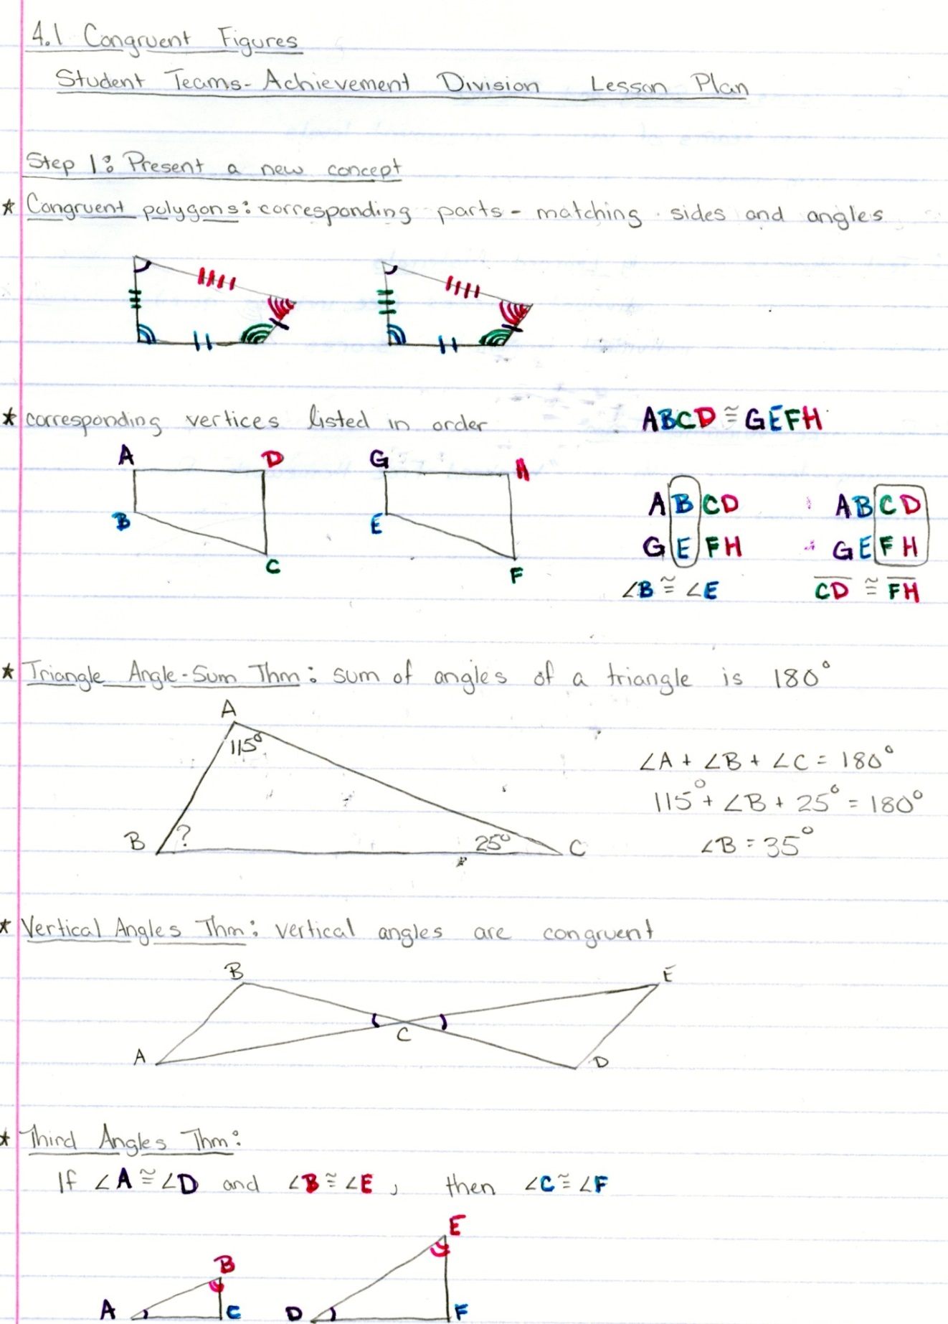

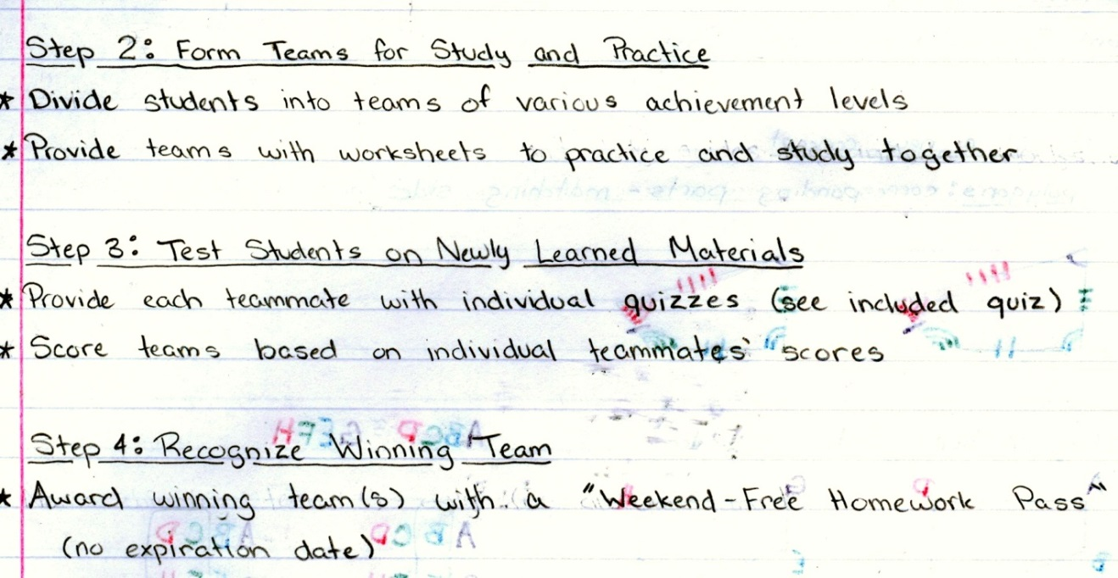

STAD Worksheet

- Given: ΔQXR ≅ ΔNYC
- QX ≅ .
- ∠Y ≅ .

- Given: BAND ≅ LUCK
- ∠U ≅ .
- DB ≅ .
- NDBA ≅ .

- In ΔMAP and ΔTIE, ∠A ≅ ∠I and ∠P ≅ ∠E.
- What is the relationship between ∠M and ∠T?
- If m∠A = 52 and m∠P = 36, what is m∠T?

- Suppose POLY SIDE
- List the four pairs of congruent sides.
- List the four pairs of congruent angles.

Given ABCD ≅ EFGH, find each of the following based on the figures below.
128°
280
52°
52°
128°
335
45
45
A
B
C
D
E
F
G
H

- AD 6. GH 7. m∠GHE 8. m∠BCD

Fill in the blanks with the missing statements and reasons.

A
B
C
D

Given: AB ║ DC, ∠B ≅ ∠D, AB ≅ DC, BC ≅ AD
Prove: ΔABC ≅ ΔCDA
Statements | Reasons
- AB ║ DC, ∠B ≅ ∠D, AB ≅ DC, BC ≅ AD | 1. A .
- ∠BAC ≅ ∠DCA | 2. B .
- C . | 3. Third Angles Theorem
- D . | 4. Reflexive Property
- ΔABC ≅ ΔCDA | 5. E .

STAD Worksheet (Solutions)

- Given: ΔQXR ≅ ΔNYC
- QX ≅ NY
- ∠Y ≅ ∠X

- Given: BAND ≅ LUCK
- ∠U ≅ ∠A
- DB ≅ KL
- NDBA ≅ CKLU

- In ΔMAP and ΔTIE, ∠A ≅ ∠I and ∠P ≅ ∠E.
- What is the relationship between ∠M and ∠T?
∠M = ∠T
- If m∠A = 52 and m∠P = 36, what is m∠T?
92

- Suppose POLY SIDE
- List the four pairs of congruent sides.
PO ≅ SI, OL ≅ ID, LY ≅ DE, YP ≅ ES
- List the four pairs of congruent angles.
∠P ≅ ∠S, ∠O ≅ ∠I, ∠L ≅ ∠D, ∠Y ≅ ∠E

Given ABCD ≅ EFGH, find each of the following based on the figures below.
128°
280
52°
52°
128°
335
45
45
A
B
C
D
E
F
G
H

Fill in the blanks with the missing statements and reasons.
A
B
C
D

Given: AB ║ DC, ∠B ≅ ∠D, AB ≅ DC, BC ≅ AD
Prove: ΔABC ≅ ΔCDA
Statements | Reasons
- AB ║ DC, ∠B ≅ ∠D, AB ≅ DC, BC ≅ AD | 1. Given
- ∠BAC ≅ ∠DCA | 2. Alternate Interior Angles
- ∠BCA ≅ ∠DAC | 3. Third Angles Theorem
- AC ≅ AC | 4. Reflexive Property
- ΔABC ≅ ΔCDA | 5. Definition of Congruent Triangles

STAD Quiz
- If ΔWYS ≅ ΔMKV, what are the congruent corresponding parts?
- Suppose that ΔWYS ≅ ΔMKV. If m∠W = 62 and m∠Y = 35, what is m∠V? Explain?
- Is ΔABD ≅ ΔCBD? Justify your answer.
D

C
A
B

- Given: ∠A ≅ ∠D, AE ≅ DC, EB ≅ CB, BA ≅ BD
Prove: ΔAEB ≅ ΔDCB
C
A
D
E
B

STAD Quiz (Solutions)
- If ΔWYS ≅ ΔMKV, what are the congruent corresponding parts?
WY ≅ MK, YS ≅ KV, WS ≅ MV
∠WYS ≅ ∠MKV, ∠YSW ≅ ∠KVW, ∠SWY ≅ ∠VMK
- Suppose that ΔWYS ≅ ΔMKV. If m∠W = 62 and m∠Y = 35, what is m∠V? Explain?
m∠V = 83.
m∠W + m∠Y + m∠S = 180 (triangle angle sum theorem).
m∠S = 83 and m∠S ≅ m∠V (definition of congruence).
- Is ΔABD ≅ ΔCBD? Justify your answer.
Although we know AD ≅ DC (given) and DB ≅ DB (reflexive property) we don’t have enough additional information to prove ΔABD ≅ ΔCBD.
D

C
A

B

- Given: ∠A ≅ ∠D, AE ≅ DC, EB ≅ CB, BA ≅ BD
Prove: ΔAEB ≅ ΔDCB
∠A ≅ ∠D (given)
∠ABE ≅ ∠DBC (vertical angles theorem)
∠AEB ≅ ∠DCB (third angles theorem)
ΔAEB ≅ ΔDCB (definition of congruent triangles)
C
A
D
E
B

Logo Design

Teacher Name: Ms. Staggs
Student Name: ________________________________________

CATEGORY | 4 | 3 | 2 | 1 | Score
Color Choices | Choice and application of color shows an advanced effort of color relationships. Color choice enhances the idea being expressed. | Choice and application of color shows effort of color relationships. Colors are appropriate for the idea being expressed. | Choice and application of color shows effort of color relationships. Colors are, however, NOT appropriate for the idea being expressed. | Student needs to work on learning color relationships and using that knowledge in his/her work.
Creativity | Student has taken the technique being studied and applied it in a way that is totally his/her own. The student\'s personality/voice comes through. | Student has taken the technique being studied and has used source material as a starting place. The student\'s personality comes through in parts of the design. | Student has copied some design from the source material. There is little evidence of creativity, but the student has done the assignment. | Student has not made much attempt to meet the requirements of the assignment.
Time/Effort | Much time and effort went into the planning and design of the logo. It is clear the student put in a lot of time at home. | Student could have put in more time and effort at home. | It is evident student did do some work at home. | Student put in no additional effort.

STAD Homework

3. Triangles MNO and PQR are congruent. Match each segment or angle below with its corresponding part in the list on the right by typing its letter in the box provided. |  |  | 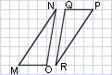
 |  | a.
 |  | b.
 |  | c.
 |  | d.
 |  | e.
 |  | f.

4. Which of the figure(s) below are congruent to figure A? 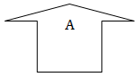
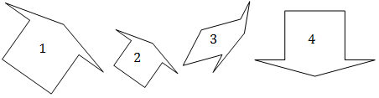
5. Are these two figures congruent? Explain your answer.

6. Which of the following is not a reason two figures are congruent?
- Same shape
- Same number of sides
- Same angle measurements
- Equal line segments
7. Which of the following figures may be congruent to figure below?
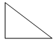
- Square of the same size
- Equilateral triangle
- Right triangle of the same size
- Right triangle of a greater size

STAD Homework (and Solutions)
3. Triangles MNO and PQR are congruent. Match each segment or angle below with its corresponding part in the list on the right by typing its letter in the box provided.
 | A | a.
 | C | b.
 | F | c.
 | D | d.
 | B | e.
 | E | f.

4. Which of the figure(s) below are congruent to figure A?
Answer: 4

5. Are these two figures congruent? Explain your answer.
Answer: No, because they are not the same size.

6. Which of the following is not a reason two figures are congruent?
- Same shape
- Same number of sides
- Same angle measurements
- Equal line segments
Answer: 3. Same angle measurements.
7. Which of the following figures may be congruent to figure below?
- Square of the same size
- Equilateral triangle
- Right triangle of the same size
- Right triangle of a greater size
Answer: 3. Right triangle of the same size

